**Practical – 02**

STEP 1: OPEN UNITY CREATE A NEW PROJECT AFTR CREATING PROJECT RIGHT CLICK ON LEFT SIDE OF SCREEN AND CREATE A EMPTY OBJECT.

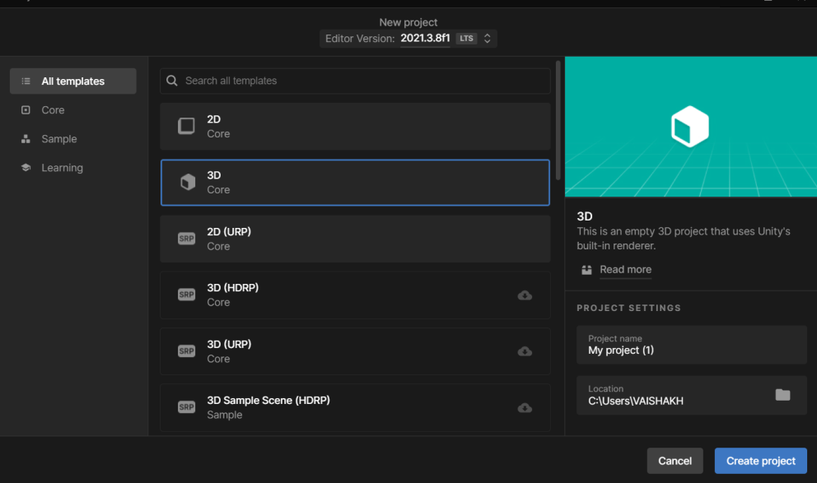

RENAME THE OBJECT ACCORDINGLY....

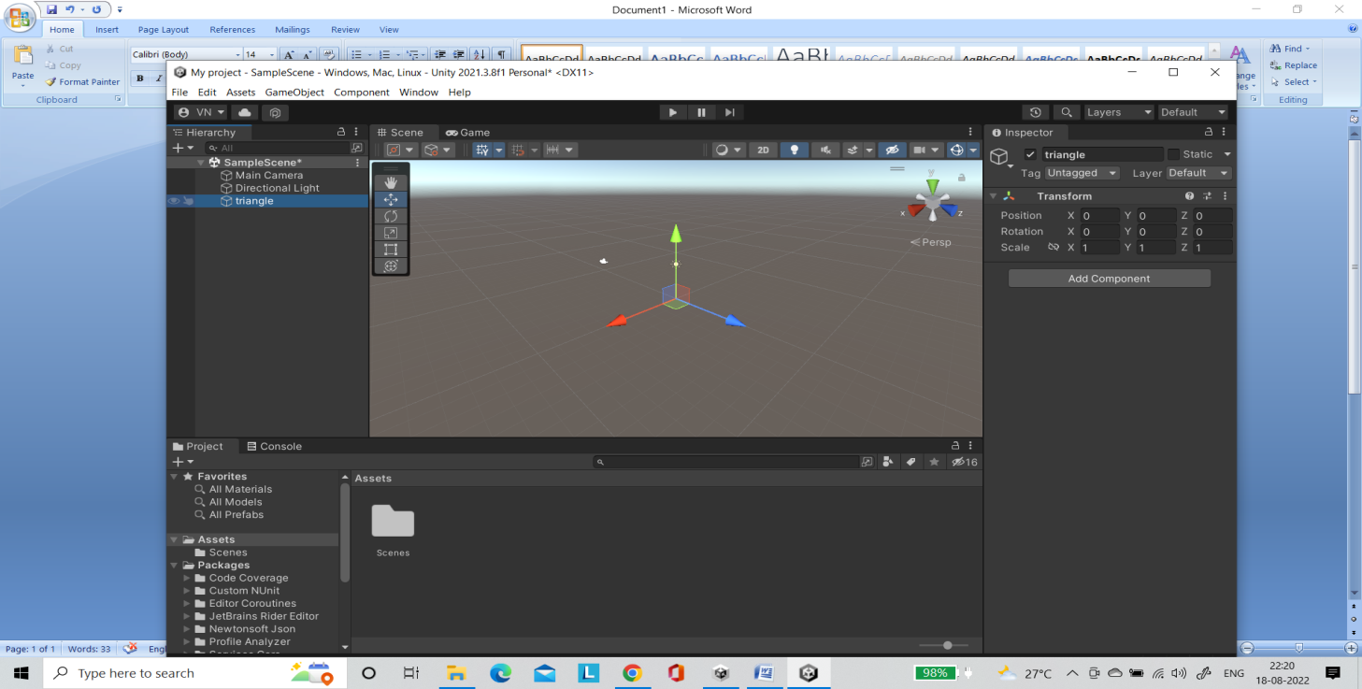

CLICK ON THE OBJECT AND CLICK ON ADD COMPONENTS AND ADD MESH COMPONENTS

SELECT MESH FILTER AND MESH RENDERER ...

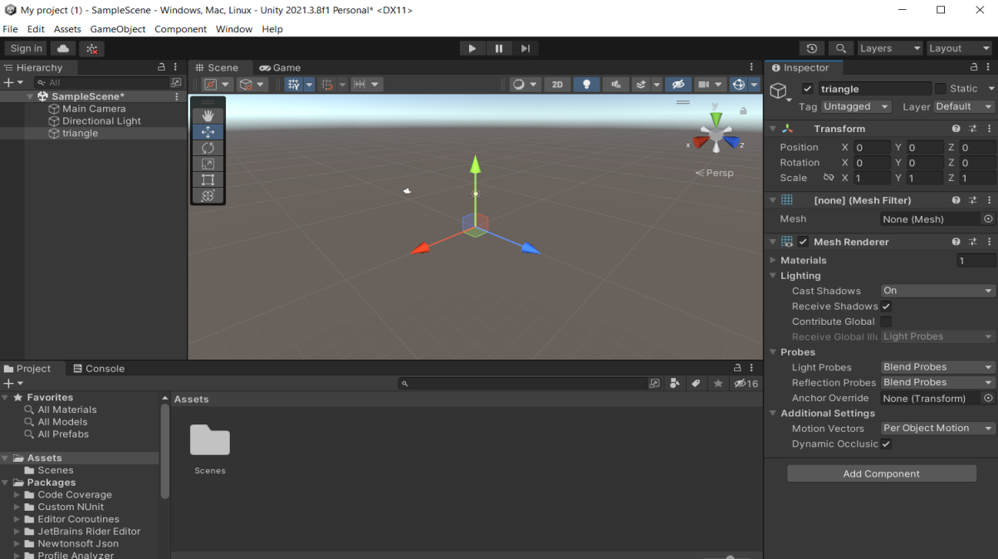

CREATE A ASSET AND SELECT C# SCRIPT

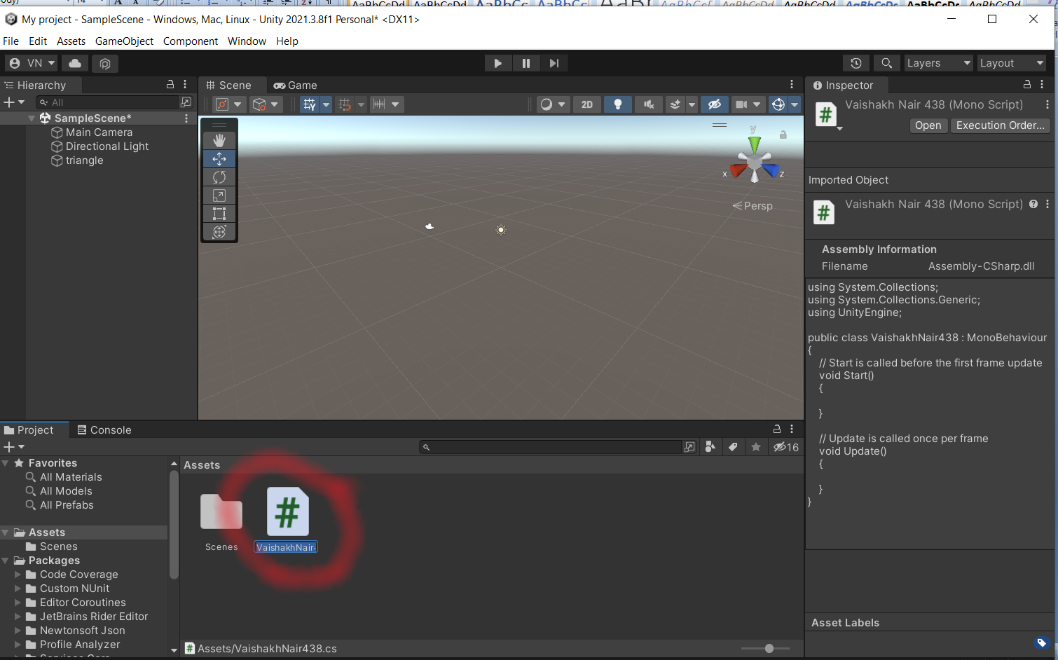

STEP4: Double Click the Asset file and start typing the code given:

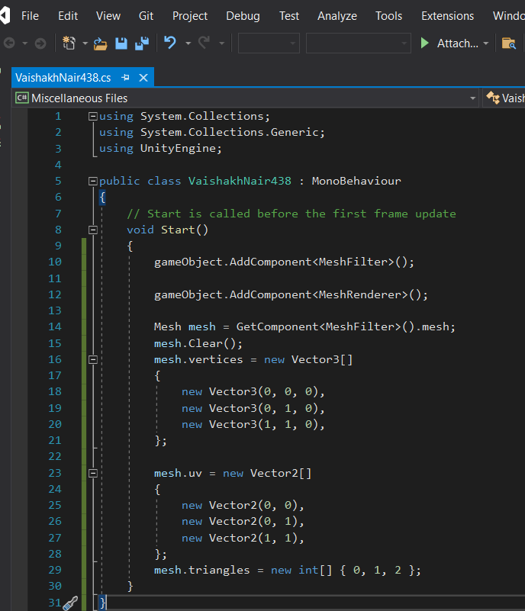

SELECT THE SCALE AND POSITION RESPECTIVE FOR SIZE OF TRIANGLE OR USE MOUSE...

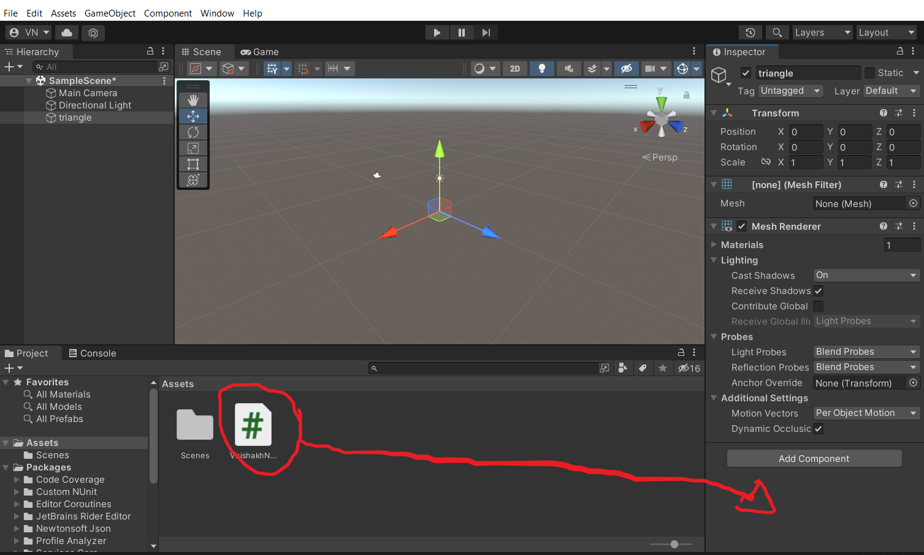

STEP 6 : Run THE APPLICATION

